**OPEN SOURCE PROGRAMMING ITE1008**

**2020**

**J-COMPONENT FINAL REPORT**

**BLOOD BANK MANAGEMENT SYSTEM**

***Effort By -***

## **19BIT0348 B.K. Anirudh**

## 

**19BIT0333 B. Manish**

**19BIT0061 L. Jaswanth**

**19BIT0189 Lakshmi Nivas**

B2+TB2

***UNDER THE GUIDANCE OF***

# PROF. JAYAKUMAR SIR VIT UNIVERSITY, VELLORE



**ABSTRACT :**

-- The main aim to help needy people in case of emergencies.

-- Blood donor play very important role in the healthcare of patients in our community.

-- Most population are eligible to donate blood yet very few actually do.

-- Every year, a huge number of individuals depend on accepting and giving blood

to remain alive.

-- So, we have created a platform for blood donors where they can fill their

details and our team

will reach their locations for safe blood transfusion.

-- Blood bank may be one of the absolute best instances of unselfishness in real life for

fulfilling the Need of blood to people.

# INTRODUCTION

* The project BLOODBANK SYSTEM is a project that is designed

for a blood bank to gather blood from various sources and

distribute it to the needy people who have high requirements for it.

* The software is designed to handle daily transactions of

blood bank and search the details when required.

* It also helps to register the details of donor, blood collection

details as well as blood issued reports.

* The software application is designed in such a manner that it

can the needs of all blood bank requirements in the course of

future.

# GOALS AND OBJECTIVES

The goals and objectives of the Blood Bank Management System are as

follows:

* To provide a means for the blood bank to publicize and advertise blood donation programs.
* To allow the probable recipients to make search and match the volunteer donors, and make request for the blood.
* To provide an efficient donor and blood stock management functions to the blood bank by recording the donor and blood details.
* To improve the efficiency of blood stock management by alerting the blood bank staffs when the blood quantity is below it par level or when the blood stock has expired.
* To provide synchronized and centralized donor and blood stock database.
* To provide immediate storage and retrieval of data and information.

# EXISTING SYSTEM

* Time consuming

* Leads to error prone results * Consumes lot of manpower * Lacking of donor information

* Uncertainty of Donor availability * Retrieval of data takes lot of time * Percentage of accuracy is less

# PROPOSED SYSTEM

* + Access from anywhere of world
  + Access at any time
  + Quick Search
  + Better Communication
  + Optimize to volunteer
  + Time Optimize
  + Cost Optimize

# WORKING MODULE

#### E.R DIAGRAM

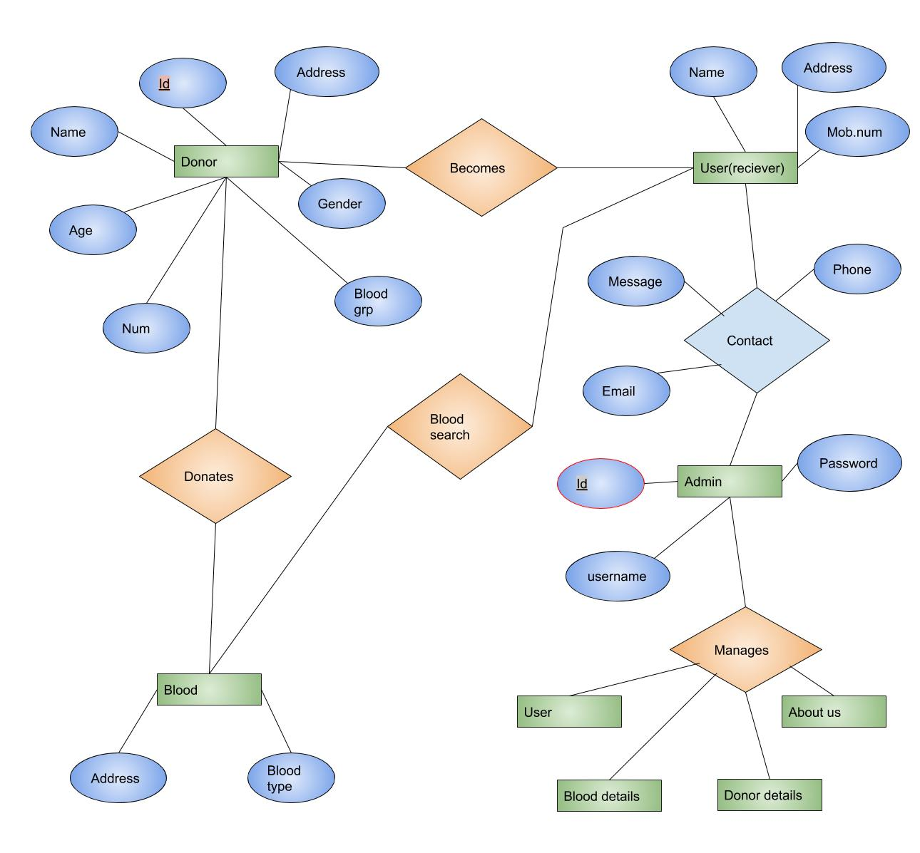

**E.R Diagram of project.**

Donor entity have name, age, blood group, mobile no, address, gender and id attributes which have relation with donates blood and blood type where blood entity has relation with search blood which has relation with user/receiver and user have relation with contact entity which can be managed by the admin panel for that you required ‘username’ and ‘password’ which manages ‘User’, ‘Blood details’, ‘Donor Details’ and ‘About us’ page.

**i) DATA FLOW DIAGRAM**

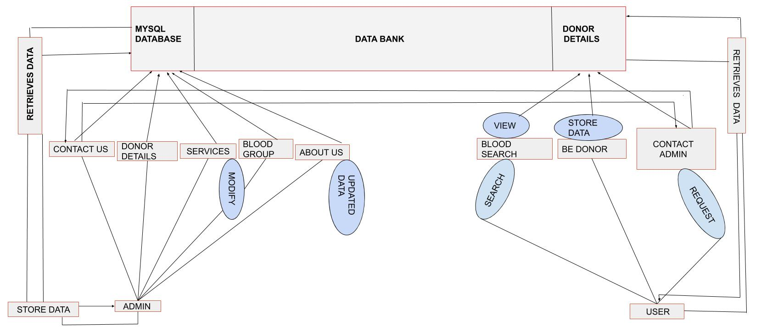

**State or data flow diagram.**

# ADVANTAGE

* Access from anywhere of world
* Access at any time
* Quick Search
* Better Communication
* Optimize to volunteer
* Time Optimize
* Cost Optimize

# DISADVANTAGE

* At present it is available for some limited zone.
* Problem to calculate number of donor available in list.
* Difficulty in identifying blood donor’s expiry date.
* In future we must overcome this drawback by using modern technologies.

THANK YOU